COMPAS Dashboard
Implementation Guide
Streamlit Dashboard for Interpretable & Fair Recidivism Prediction

Prepared for: Data and Cloud
Cloud Deployment Demo: March 30, 2026
NOTE: The figures in this document might not be accurate for our project, change as needed. I just needed some example numbers to get points across.

Table of contents
1. Design System & Color Palette
2. Page Structure & Navigation
3. Page 1: Home Dashboard
4. Page 2: Prediction Tool
5. Page 3: Fairness Analysis
6. Page 4: Model Comparison
7. Page 5: Geographic Generalization
8. Page 6: About
9. Technical Implementation Notes
10. File Structure & Dependencies
11. Picture mockups

1. Design system & color palette

1.1 Color palette (Ocean Gradient theme)
Use these exact hex values for consistency across all pages:
Color Name | Hex Code | Usage
Primary Navy | #0F172A | Sidebar background, dark headers
Secondary Navy | #1E3A5F | Sidebar gradient end, secondary elements
Accent Blue | #0EA5E9 | Primary accent, active states, links, highlights
Cyan | #06B6D4 | Secondary accent, subtitles
Success Green | #10B981 | Fair status, positive metrics, Georgia data
Warning Amber | #F59E0B | Moderate status, warnings
Danger Red | #EF4444 | Unfair status, high risk, errors
Text Primary | #1E293B | Main body text
Text Muted | #64748B | Secondary text, labels, captions
Light Gray | #F8FAFC | Page background
Border Gray | #E2E8F0 | Card borders, dividers

1.2 Typography
Element | Size | Style
Page Title | 20-22px | Font-weight: 500, color: text-primary
Section Header | 14-16px | Font-weight: 500, color: text-primary
Body Text | 13-14px | Font-weight: 400, color: text-primary
Labels/Captions | 11-12px | Font-weight: 400, color: text-muted (#64748B)
Metric Values | 24-28px | Font-weight: 500, color varies by context

1.3 Component styles

Cards
- Background: white (#FFFFFF)
- Border: 0.5px solid #E2E8F0
- Border-radius: 12px
- Padding: 16-20px
- Shadow (optional): 0 2px 8px rgba(0,0,0,0.08)

Metric cards
- Background: #F8FAFC (light gray)
- Border-radius: 8px
- Padding: 16px
- Label: 12px muted text above
- Value: 24px bold below

Status badges
- Fair/Good: background #DCFCE7, text #166534
- Warning/Moderate: background #FEF3C7, text #92400E
- Unfair/Bad: background #FEE2E2, text #991B1B
- Info: background #DBEAFE, text #1E40AF
- Padding: 4px 12px, border-radius: 12px (pill shape)

2. Page structure & navigation

2.1 Sidebar navigation
The sidebar should have two states: expanded (220px) and collapsed (56px). Use Streamlit's native sidebar with custom CSS styling.

Navigation items
Icon | Page Name | File Name
🏠 | Home | pages/1_🏠_Home.py
🎯 | Prediction tool | pages/2_🎯_Prediction.py
⚖️ | Fairness analysis | pages/3_⚖️_Fairness.py
📊 | Model comparison | pages/4_📊_Models.py
🗺️ | Generalization | pages/5_🗺️_Generalization.py
ℹ️ | About | pages/6_ℹ️_About.py

Sidebar CSS styling
Add this to .streamlit/config.toml or inject via st.markdown:
[theme]primaryColor = '#0EA5E9'backgroundColor = '#F8FAFC'secondaryBackgroundColor = '#FFFFFF'textColor = '#1E293B'

3. Page 1: Home dashboard

3.1 Layout overview
The home page provides a high-level overview of the dataset and model performance. It should load quickly and give users immediate insights.

Components (top to bottom)
- Header: Page title + subtitle + dataset selector dropdown
- Metric cards row: 4 cards in a row (use st.columns(4))
- Charts row: 2 charts side by side (use st.columns(2))
- CTA banner: Call-to-action linking to prediction tool

3.2 Metric cards
Metric | Value | Subtext | Color
Total records | 7,214 | Florida dataset | Green (#10B981)
Recidivism rate | 45.1% | 2-year window | Amber (#F59E0B)
Best model AUC | 0.74 | Random Forest | Blue (#0EA5E9)
Disparate impact | 0.58 | Below 0.8 threshold | Red (#EF4444)

3.3 Charts

Chart 1: Recidivism rate by race (horizontal bar)
- African American: 52.3% (color: #0EA5E9)
- Caucasian: 39.2% (color: #1E3A5F)
- Hispanic: 35.4% (color: #06B6D4)
- Other: 41.1% (color: #64748B)
- Use: st.plotly_chart() with go.Bar(orientation='h')

Chart 2: Model performance comparison (horizontal bar)
- COMPAS: 65.4% (color: #64748B)
- Logistic Regression: 67.2% (color: #0EA5E9)
- Random Forest: 69.1% (color: #10B981)
- Decision Tree: 66.3% (color: #8B5CF6)

4. Page 2: Prediction tool

4.1 Layout
Two-column layout: input form on left (340px), results on right (flex).

4.2 Input form fields
Field | Type | Options/Range
Age | st.number_input | min=18, max=80, default=34
Sex | st.selectbox | ['Male', 'Female']
Race | st.selectbox | ['African American', 'Caucasian', 'Hispanic', 'Other'] (we can choose not to include Hispanic or Other)
Prior crimes count | st.number_input | min=0, max=40, default=3
Juvenile felonies | st.number_input | min=0, max=10, default=0
Charge degree | st.selectbox | ['Felony', 'Misdemeanor']
Model | st.selectbox | ['Logistic Regression', 'Random Forest', 'Decision Tree', 'XGBoost + Debiasing']

4.3 Results display

Risk gauge
- Circular gauge showing prediction probability (0-100%)
- Use Plotly gauge chart: go.Indicator(mode='gauge+number')
- Color ranges: 0-30% green, 30-60% amber, 60-100% red
- Below gauge: status badge ('Low risk', 'Medium risk', 'High risk')

Multi-model comparison
- Run same input through all models
- Show horizontal bar for each model's prediction
- Helps user understand model variance

SHAP waterfall explanation
- Show feature contributions to prediction
- Use shap.plots.waterfall() or custom Plotly implementation
- Red bars = increases risk, Green bars = decreases risk
- Start from base value (population average), end at prediction
- Include interpretation text box below explaining key drivers

5. Page 3: Fairness analysis

5.1 Controls
- Protected attribute selector: Race (default), Sex
- Model selector: Random Forest, Logistic Regression, Decision Tree

5.2 Fairness metrics cards (4 columns)
Metric | Value | Status | Threshold
Disparate Impact (DI) | 0.58 | Unfair (red) | ≥0.8 is fair
Statistical Parity Diff (SPD) | -0.18 | Unfair (red) | ±0.1 is fair
Equal Opportunity Diff (EOD) | -0.12 | Moderate (amber) | ±0.1 is fair
Equalized Odds Diff | -0.09 | Moderate (amber) | ±0.1 is fair

5.3 Charts

Chart 1: Error rates by demographic group
- Side-by-side bar charts for FPR and FNR
- FPR: African American 44.8%, Caucasian 23.5%
- FNR: African American 28.0%, Caucasian 47.7%
- Highlight: African Americans have 1.9x higher FPR

Chart 2: Calibration plot
- Scatter plot: predicted probability vs actual recidivism rate
- Separate series for each demographic group
- Include ideal diagonal line (perfect calibration)

5.4 Debiasing comparison table
Method | Accuracy | AUC | DI | SPD | Status
Baseline | 69.1% | 0.74 | 0.58 | -0.18 | Unfair
Reweighing | 66.8% | 0.71 | 0.72 | -0.11 | Improved
Equalized Odds | 64.2% | 0.68 | 0.85 | -0.05 | Fair
Reject Option (recommended) | 65.5% | 0.70 | 0.81 | -0.07 | Fair

6. Page 4: Model comparison

6.1 Model cards (4 columns)
Display 4 model cards side by side. Highlight 'Recommended' model (Logistic Regression) with blue border.
Model | Accuracy | AUC | Precision | Recall | Tags
COMPAS | 65.4% | 0.68 | 0.63 | 0.59 | Black-box, Unfair
Logistic Reg. | 67.2% | 0.72 | 0.66 | 0.64 | Interpretable
Random Forest | 69.1% | 0.74 | 0.68 | 0.66 | Best accuracy
Decision Tree | 66.3% | 0.70 | 0.64 | 0.62 | Interpretable

6.2 ROC curves
- Use sklearn.metrics.roc_curve() for each model
- Plot all 4 curves on same chart with legend showing AUC
- Include diagonal reference line (random classifier)
- Colors: RF=#10B981, LR=#0EA5E9, DT=#8B5CF6, COMPAS=#64748B

6.3 Confusion matrix
- Dropdown to select model
- 2x2 grid with colored cells: TN (green), TP (blue), FP (red), FN (amber)
- Show count in each cell
- Use Plotly heatmap or custom HTML/CSS

7. Page 5: Geographic generalization

7.1 Research question banner
Dark gradient banner (#0F172A to #1E3A5F) displaying: "Do recidivism models trained in one jurisdiction generalize to another?"

7.2 Transfer performance cards (3 columns)
Scenario | Accuracy | AUC
Florida → Florida (baseline) | 69.1% | 0.74
Florida → Georgia (transfer) | 61.3% | 0.65 (-7.8% drop)
Georgia → Georgia (retrained) | 67.8% | 0.72

7.3 Feature importance comparison chart
- Grouped horizontal bar chart showing importance in FL vs GA
- Features: priors_count, age, juv_fel_count, offense_type, sex
- Florida bars in blue (#0EA5E9), Georgia bars in green (#10B981)

7.4 Dataset comparison table
Attribute | Florida | Georgia
Records | 7,214 | 25,835
Recidivism rate | 45.1% | 52.3%
Mean age | 34.8 | 31.2
% African American | 51% | 62%
Avg prior crimes | 2.7 | 3.4

7.5 Key findings section
Display 3 colored info boxes:
- Performance gap (amber): 7.8% accuracy drop when transferring
- Transferable features (green): priors_count and age remain strong in both
- Recommendation (blue): Retrain models on local data

8. Page 6: About

8.1 Project overview banner
Dark gradient banner with project title, description, and 4 stat counters (4 RQs, 33K+ records, 5 models, 2 states).

8.2 Sections to include
- Research questions: List all 4 RQs with badges (RQ1-RQ4)
- Team members: Avatar + name + role for each of 6 team members
- Data sources: COMPAS (Florida) and NIJ (Georgia) with record counts
- Technology stack: Pill badges for Python, Scikit-learn, XGBoost, AIF360, SHAP, Streamlit, Plotly, Pandas
- Key references: Dressel & Farid (2018), Rudin et al. (2020), Wang et al. (2022)
- Footer: University of Alberta, INT D 491 B1, Winter 2026

9. Technical implementation notes

9.1 Streamlit configuration
# .streamlit/config.toml[theme]primaryColor = '#0EA5E9'backgroundColor = '#F8FAFC'secondaryBackgroundColor = '#FFFFFF'textColor = '#1E293B'font = 'sans serif'[server]headless = trueport = 8501

9.2 Custom CSS injection
Add at top of each page for consistent styling:
st.markdown('''<style> .stMetric { background: #F8FAFC; padding: 16px; border-radius: 8px; } .stMetric label { color: #64748B; font-size: 12px; } .stMetric [data-testid="metric-value"] { font-size: 24px; font-weight: 500; } div[data-testid="stSidebar"] { background: linear-gradient(180deg, #0F172A, #1E3A5F); }</style>''', unsafe_allow_html=True)

9.3 Data loading pattern
@st.cache_datadef load_data(): florida_df = pd.read_csv('data/compas_florida.csv') georgia_df = pd.read_csv('data/nij_georgia.csv') return florida_df, georgia_df@st.cache_resourcedef load_models(): models = { 'Logistic Regression': joblib.load('models/logistic_reg.pkl'), 'Random Forest': joblib.load('models/random_forest.pkl'), 'Decision Tree': joblib.load('models/decision_tree.pkl') } return models

9.4 Key libraries to install
# requirements.txtstreamlit>=1.28.0pandas>=2.0.0numpy>=1.24.0scikit-learn>=1.3.0xgboost>=2.0.0shap>=0.43.0aif360>=0.5.0plotly>=5.17.0joblib>=1.3.0

10. File structure & dependencies

10.1 Recommended project structure
compas-dashboard/├── app.py # Main entry point├── requirements.txt├── .streamlit/│ └── config.toml # Theme configuration├── pages/│ ├── 1_🏠_Home.py│ ├── 2_🎯_Prediction.py│ ├── 3_⚖️_Fairness.py│ ├── 4_📊_Models.py│ ├── 5_🗺️_Generalization.py│ └── 6_ℹ️_About.py├── utils/│ ├── __init__.py│ ├── data_loader.py # Data loading functions│ ├── models.py # Model loading & prediction│ ├── fairness.py # AIF360 fairness metrics│ ├── shap_utils.py # SHAP explanation helpers│ └── charts.py # Plotly chart functions├── data/│ ├── compas_florida.csv│ ├── nij_georgia.csv│ └── processed/ # Preprocessed data├── models/│ ├── logistic_reg.pkl│ ├── random_forest.pkl│ ├── decision_tree.pkl│ └── xgboost_debiased.pkl└── assets/ └── style.css # Custom CSS

10.2 Deployment checklist
- Streamlit Cloud: Connect GitHub repo, set Python version to 3.10+
- Ensure all data files are under 200MB for Streamlit Cloud
- Add .gitignore for __pycache__, .pyc, .env files
- Test locally with: streamlit run app.py
- Verify all pages load without errors before demo

10.3 Demo day reminders
- Cloud Deployment Demo: March 30, 2026 (20% of grade)
- Prepare 2-3 demo scenarios with pre-filled inputs
- Have backup local deployment ready in case of internet issues
- Test on multiple browsers (Chrome, Firefox, Safari)
- Ensure mobile responsiveness (instructor may view on phone)

11. Picture Mockups

11.1 Home Page
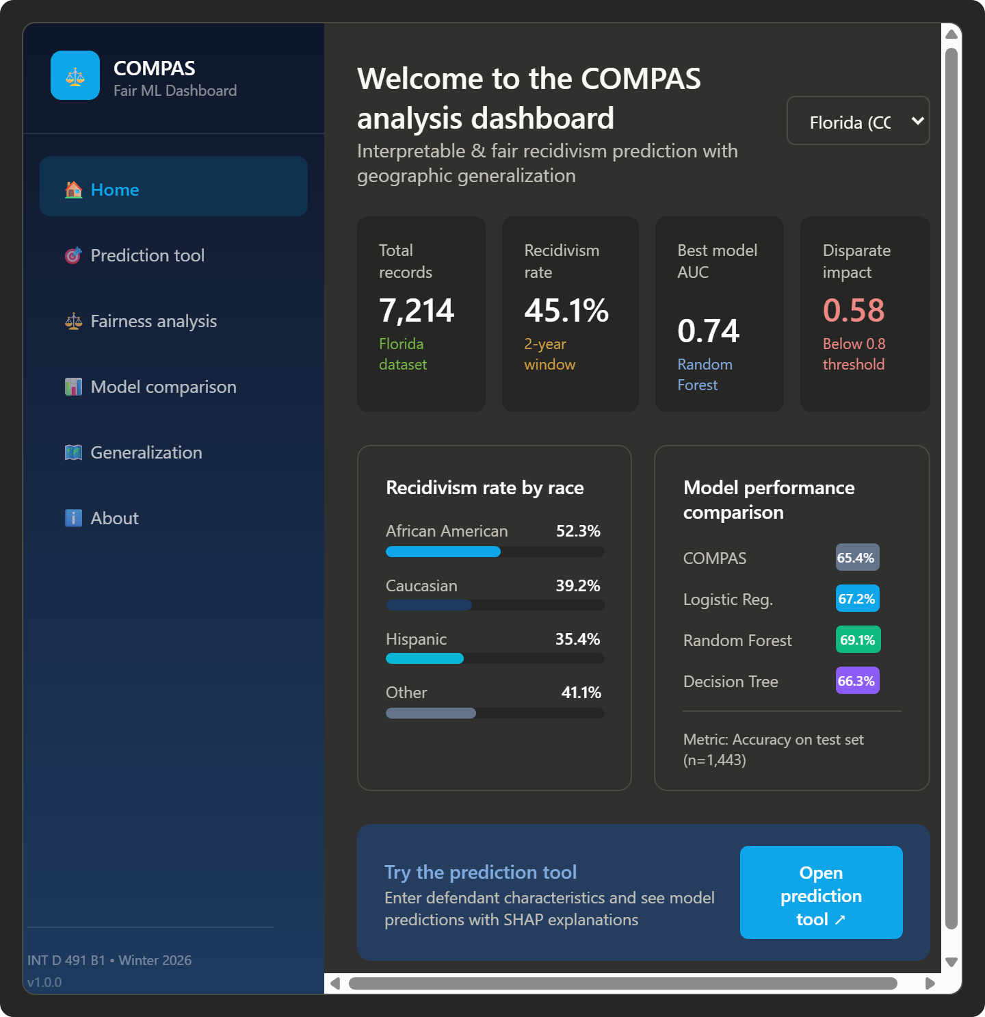

11.2 Prediction Tool Page
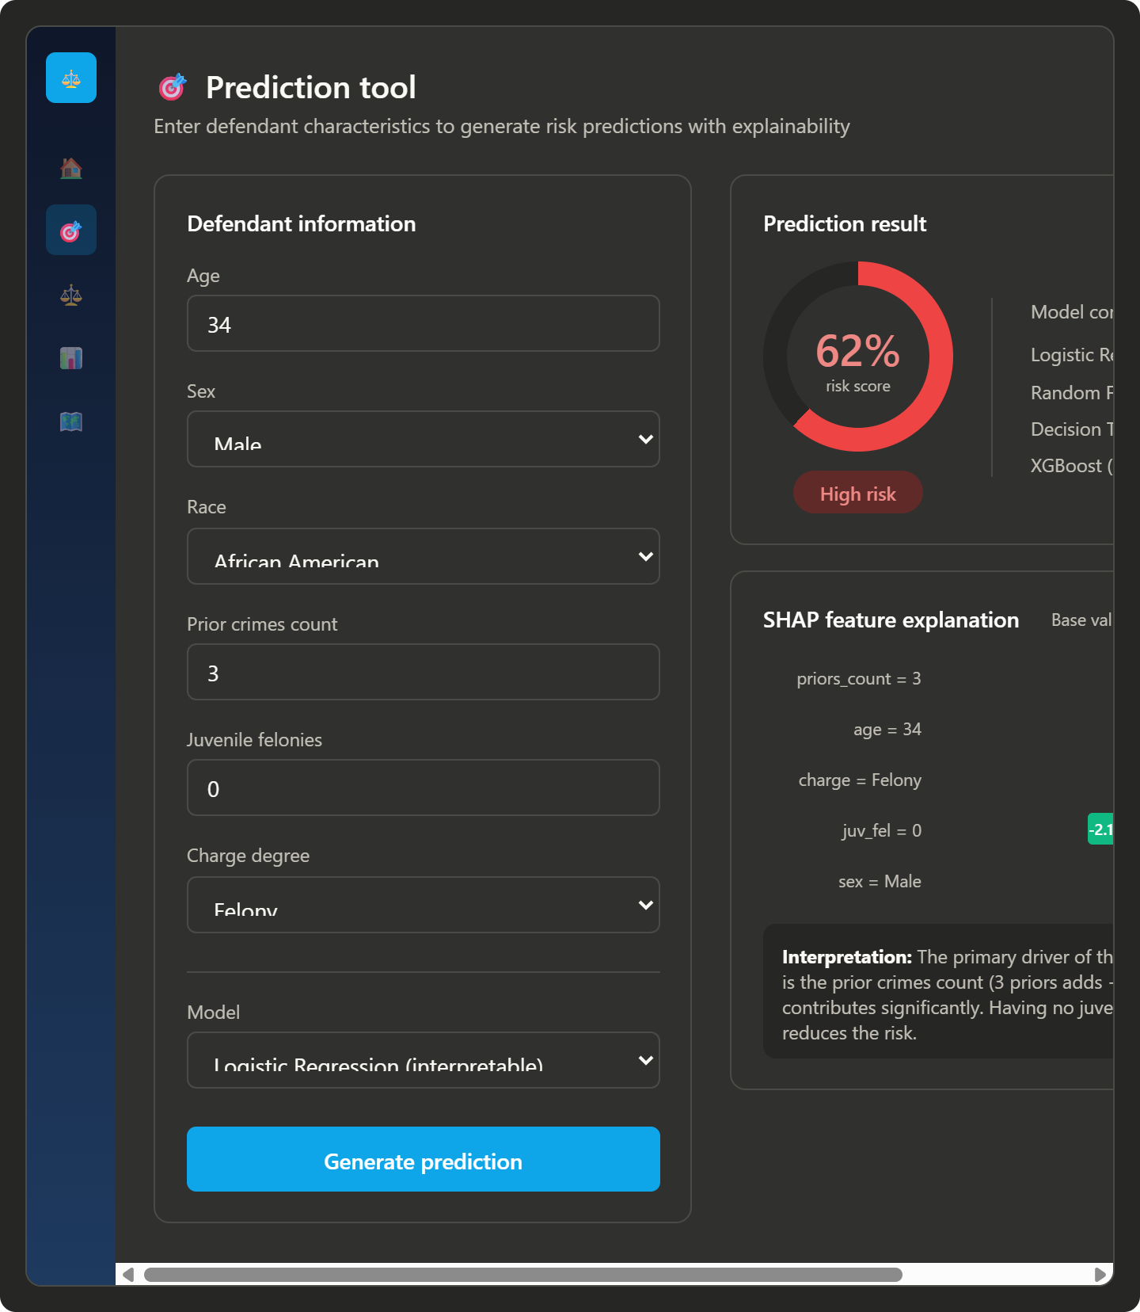

11.3 Fairness Analysis Page
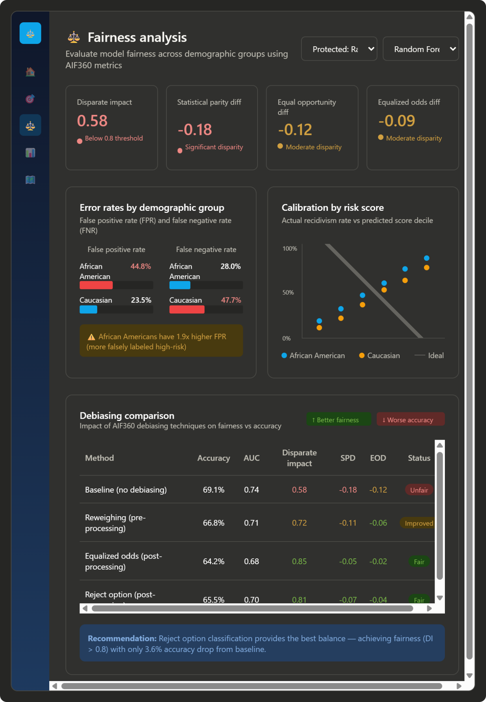

11.4 Geographic Generalization Page
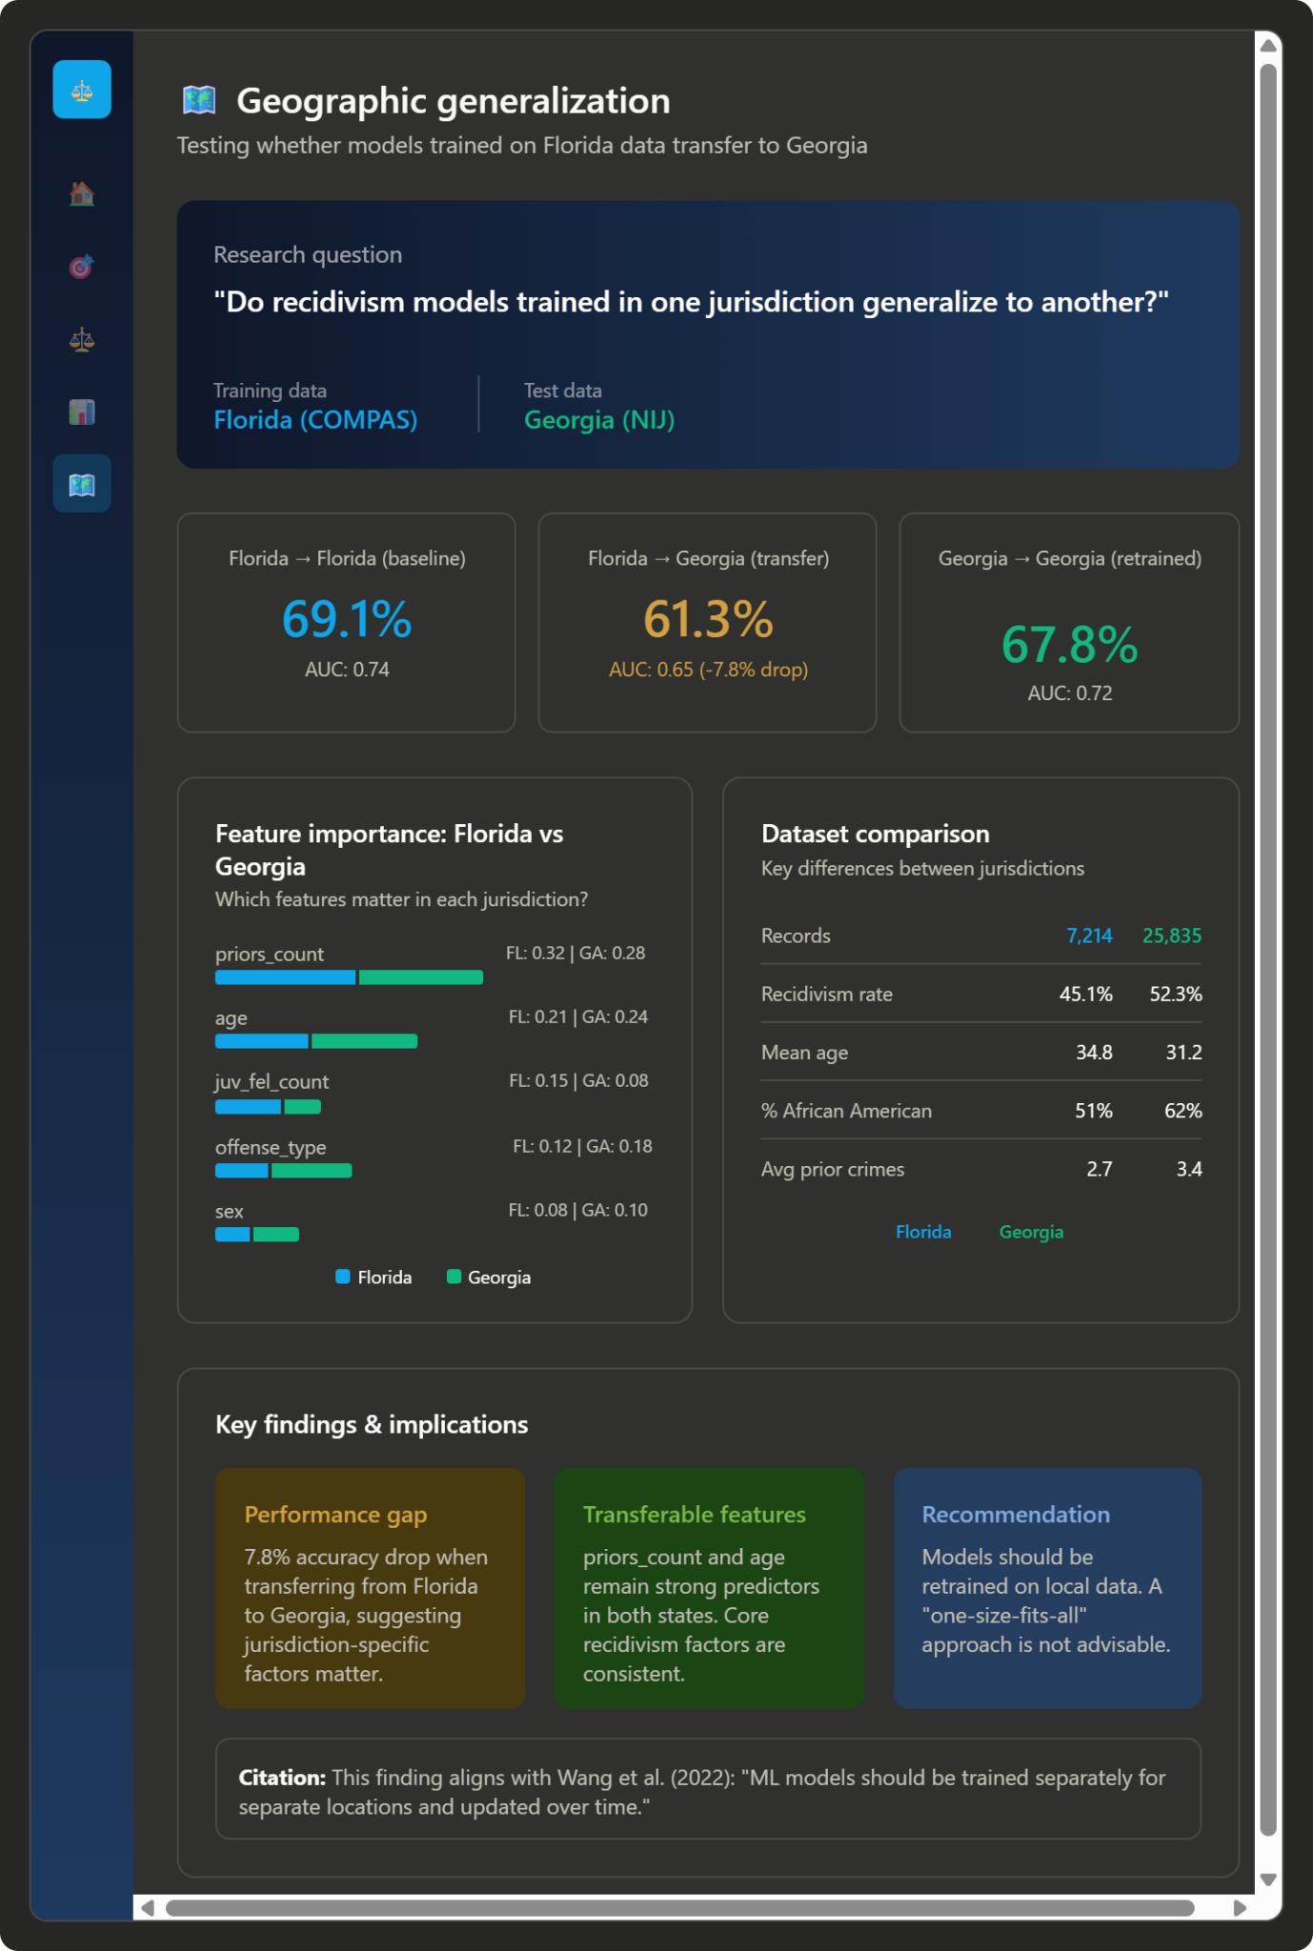

11.5 Model Comparison Page
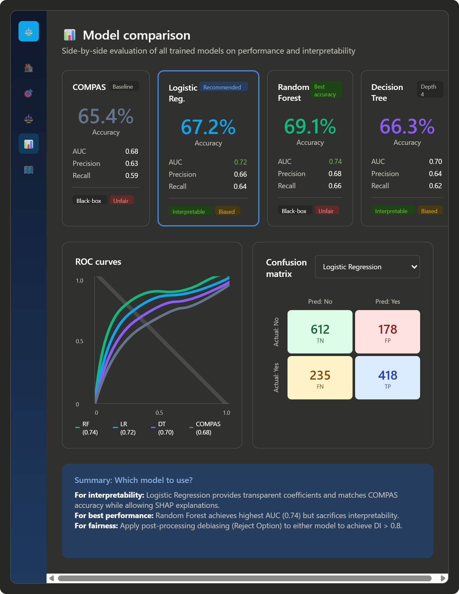

11.6 About Page
